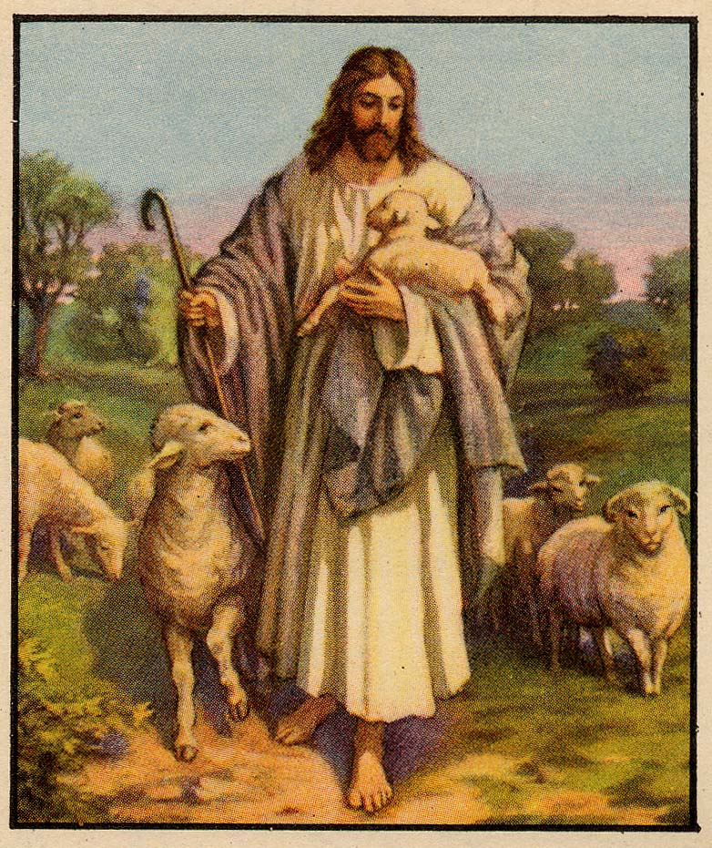
Vol. 54 January, 2013 No. 1
FROM THE PASTOR
As the New Year approaches we are reminded once again of the fresh start we are offered. Many of us make New Year resolutions hoping we will change and our lives will improve.
As Disciples of Jesus Christ an invitation to receive life and receive it abundantly is always ours each day. John Wesley’s covenant service calls us in this New Year to renew and commit ourselves to Christ. Here is the invitation.
Commit yourselves to Christ as his servants.
Give yourselves to him, that you may belong to him.
Christ has many services to be done.
Some are more easy and honorable, others are more difficult and disgraceful.
Some are suitable to our inclinations and interests, others are contrary to both.
In some we may please Christ and please ourselves.
But then there are other works where we cannot please Christ except by denying ourselves.
It is necessary, therefore, that we consider what it means to be a servant of Christ.
Let us, therefore, go to Christ, and pray:
Let me be your servant, under your command.
I will no longer be my own.
I will give up myself to your will in all things.
Be satisfied that Christ shall give you your place and work.
Lord, make me what you will.
I put myself fully into your hands:
put me to doing, put me to suffering, let me be employed for you, or laid aside for you, let me be full, let me be empty, let me have all things, let me have nothing. I freely and with a willing heart give it all to your pleasure and disposal. With God’s richest blessings and hopes for the New Year. Pastor Lowell
January’s Potluck
Paul instructed us to wisely use our God-given talents for the benefit of others. The medical staff of doctors, nurses, and medical technicians at the Mission Medical Clinic follows these instructions by donating their time and talents to heal the sick of body, mind, and soul. The program for the January Potluck will be presented by Ben Wentworth to illustrate what is accomplished at the clinic along with the role our church had and is having in helping the clinic with their mission. So bring your favorite soup or salad, join in warm fellowship, and learn more what God, through his servants, is accomplishing in our community. Join us January 13 at 6:00 p.m. for a SOUP potluck. Bring your favorite soup or chili and or salads and of course desserts!!
Angola: Saving Lives With Nets
Everyone Welcome

Join the United Methodist Women on February 2 to hear Burl Kreps, retired pastor who served here from 1973-1984, speak of his recent trip to Angola, Africa, and the work being done there to rid the nation of malaria, one net at a time.
Burl was one of six, including the Bishop, from the Mountain Sky area of Yellow-stone and Rocky Mountain Conferences to travel to Angola this last October to deliver anti-malaria nets.
Burl’s presentation will begin at 9:30 a.m. on Saturday, February 2. The UMW will meet briefly at 9:00 a.m., and anyone is welcome to join our meeting, also.
Please be with us for this insightful presentation by our friend and former pastor, Burl Kreps. Mary Ann Tabor
Pledge Card Reminder
It is not too late to turn your pledge cards in. They are a vital tool in doing our church financial planning. There are extra pledge cards at the welcome center, please fill them in and drop in the offering plate or take them to the office. Thank you and we hope you had a very blessed Christmas. Finance Committee
Your Opportunity to Serve
The Altar Flower Committee is seeking new members. The time commitment is small. We do not meet on a regular basis, only as needed. If working with flowers, to enhance our altar and the sanctuary is a passion of yours, please call Joyce Nicholson, 390-6842. Thank you.
January Worship Services
1/6 ARISE and SHINE
Isaiah 60:1-6 and Psalm
72:1-7
(The Message)
1/13 A CLEAN SWEEP
Psalm 29 and Luke 3:15-17
(The Message)
1/20 WHATEVER HE TELLS
YOU, DO IT
(The Message)
1/27 EVERY EYE WAS ON
HIM
Psalm 19:1-9 and Luke 4:14-21
(The Message)
Garage Sale Fans
Those of you that look forward to our garage sale may recall that we decided to skip the sale this coming spring. We just might have a great substitute event that will please your shopping desire. The United Methodist Women will be sponsoring a special sale - a fair trade sale - that will be held in April. This sale does not have the same objective as the garage sale and the prices won’t be the same. This sale will be a Ten Thousand Villages Sale. We will be offering gifts, décor items, art pieces, and accessories handcrafted by fairly paid artisans around the world. You’ll find items eclectic to exquisite, created from natural, recycled, and sustainable sourced materials. Fair prices are determined by a team before the items are shipped to us. Don’t expect garage sale prices, but do expect fair prices. These prices cover the cost of labor and materials, while enabling artisans to earn fair compensation for their work.
These sales create opportunities for artisans in developing countries to earn income by bringing their products and stories to our markets through long-term fair-trading relationships. The United Methodist Women try to support women and children all over the world to live quality lives, and support fair-trade as part of that objective. Although the artisans aren’t all women, some are men; we are trying to help support them through this fair-trade sale. Ninety per cent of the funds raised from the sale will go directly to Ten Thousand Villages artisans and not to the church. Up to ten percent may be used to cover advertising.
The sale will be open to the community for two days, April 19 and 20. Some items will be displayed prior to the sale just to whet your appetites and give you an idea of the kinds of items available. We will be looking for your help to advertise, set up, assist during the sale, pack up unsold items, and clean up. We will also need small display shelving for things like jewelry and scarves. If you have such an item that we could borrow during the sale, we would appreciate it. If you have an interest to help with any of these areas, please contact Joyce Nicholson or a United Methodist Women member. More information to come as we get closer to the sale date.
UMW Kickoff
We invite all women of the church to our first meeting of 2013! January 5 is the day and 9:00 a.m. is the time. The program, “Preparing our Priorities”, will be presented by Shirley Greener, hostesses are Mary Ann Tabor and Pat Nyborg, and fellowship and fun will be provided by our fantastic members. The business meeting follows our program. The Book Club will meet that same day at 11:00 a.m. We plan to discuss the book Everyday Justice, by Julie Clawson. Extra copies are on the UMW bookshelf in the conference room. On January 26, the Mile High Pikes Peak District UMW will hold the annual officer training at Good Shepherd. Our unit is sponsoring the event. About 50 women from all over the area are expected to attend.
Thanks to all of you who bought Christmas goodies at our event in December. We raised over $500 for mission projects! This money will go a long way to support a variety of causes. Thank you, thank you!!
Upcoming events: February 12 – Shrove Tuesday Pancake Supper
April 19 and 20 —10,000 Villages Fair Trade Fair Pat Nyborg, UMW President
Sub-District Event

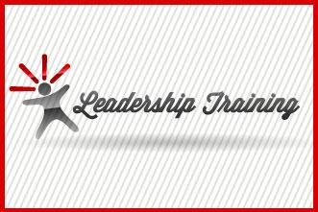

Come one, come all to the training for new committee members and anyone who is simply curious about what specific committees in the church really do. You know you’ve always wondered about it. Now you can find out for yourself.
The Pikes Peak Sub-district will host a two-hour event on Sunday afternoon, January 27, from 2:00 p.m. to 4:00 p.m. at Central UMC, right here in Colorado Springs.
Discussion groups will focus on trustees, staff parish, missions, finance/church treasurers, and lay leaders/lay members. Lay members of any congregation—whether serving on a specific committee or not—have an important position within the church. Come and learn more.
Registration is due by January 20, and registration forms are now available at the welcome center. Cost is $5 per person or $25 maximum from one congregation, regardless of the number of participants. What a deal! Questions? Call me. Mary Ann Tabor
WIRED
Happy New Year! Welcome to the year 2013! We had a great first year together! I am so very excited to continue on into another year of adventures and fun with all the youth of Good Shepherd and Stratmoor Hills United Methodist Churches!
As we bid 2012 goodbye and say hello to the New Year we will look forward to continuing our partnership with Saint Paul’s and Stratmoor Hills United Methodist Churches. We will continue to meet every Sunday from 6-7:30pm and will enjoy food, fun, and faith! The month of January looks like this for the youth of WIRED:
January 6th WIRED 6-7:30pm
January 13th NO WIRED
January 20th WIRED 6-7:30pm
January 25th Movie Night @ St. Paul’s UMC 6-8:30pm
January 27th WIRED 6-7:30pm (Game Night)
During the month of January there are opportunities to get involved with the youth of Good Shepherd UMC. Volunteer opportunities are:
Dinner for youth group on: 1/6, 1/20, 1/27 (Bring food and drinks for 15-20 people)
Helping as a chaperone on 1/25 @ St. Paul’s UMC (Movie Night)
Thank you all for your continued support! If you have any questions or concerns, please contact Seth Hastings at wired1gsumc@gmail.com or sethamus69@gmail.com . Also for continued information about WIRED, please check out our blog www.wiredgsumc.blogspot.com . The youth will also be debuting the FUSION website at the end of the month! Details will be in the February Newsletter! Have a blessed month of January! Seth
To the GSUMC Chancel Choir
I know so many of you have heard the wonderful praises from family and friends on what a great job you all did on our Christmas Cantata. I just wanted to extend my own thanks and appreciation to all of you for two awesome performances. I am truly blessed to be working with such dedicated and loving people. A special thanks to Ron for his accompaniment and patience with me. An additional thank-you needs to go to Tim for his narration. Thank-you everyone for truly demonstrating a Love Beyond Measure. Jennifer
Good News
For all of you who have been part of our church's efforts to promote Fair Trade Coffee, Tea and now Chocolate. All of these will be available after church each Sunday in Cooper Hall, sponsored by UMW. Equal Exchange, in cooperation with UMCOR, provided during 2011 over 785,000 pounds of coffee that has helped 377 family farms. Now, we thank all of you who have helped support these family farms by buying and using fair-trade coffee. More good news!! United Methodist churches such as ours now have a coffee blend to call our own. "Hope's Blend" is a special new blend in a beautifully-designed can that we will sell at the same price of $7.00. We will be selling tea for $4.00 and bags of mini-dark chocolates for $5.00.
Trusting God, No Matter What
Mile High Pikes Peak
District Conference
Wow, another great opportunity for fellowship and growth sponsored by the Mile High Pikes Peak District. On March 2, in Castle Rock, you will have the unique opportunity to hear Theresa Marchetta, news anchor for Denver’s Channel 7, speak on “Trusting God, No Matter What.” As a two-time cancer survivor and award-winning investigative reporter, Theresa is also an active United Methodist.
In addition to Ms. Marchetta’s keynote address, participants will have the opportunity to attend two workshops on such topics as: adaptive leadership, holistic stewardship, embracing change, creating sacred spaces for children, and shifting our emphasis from membership to discipleship.
Watch for more information in next month’s newsletter. Mary Ann Tabor
Music Ministries
It seems like just yesterday we were preparing our Christmas Cantata and yet it is time to begin work on the Easter Cantata. We will be doing a new cantata this Easter season that spans the life and works of Jesus called No Stone Could Hold Him by Lloyd Larson. If you are interested in participating, the rehearsals will begin at 7:00 p.m. on Wednesday, January 23 and the performances will be Saturday, March 23 and Sunday, March 24. The agreed upon participation fee is due no later than January 9. If you have any questions, please feel free to contact Jennifer Montgomery.
Lay Leader Notes
I have read a lot just today of many folks who are already putting away the Christmas decorations. All signs of the celebration of the birth of Jesus Christ are going back into the closet for another year. The outside lights will go dim, the ornaments will be carefully placed back into their boxes and the tree will be folded up and put into its container, or taken to a disposal site for burning or shredding. Perhaps this is the case around your house or apartment. Of course, even those signs and symbols that decorated our church narthex and sanctuary will be put away for another year also.
Let us hope and pray that we make absolutely sure we do not put away the Spirit of Christmas. Let us make sure that we carry that spirit forward with us each and every day of the coming year and beyond. We can always continue to “reach out and give”. The giving and receiving spirit is always within our hearts. The needs and hurts and suffering are all around us and we all have the capability to reach out and touch someone. At Good Shepherd we call one of our ministries “Inreach”, but it is really a way of reaching out to members of the congregation who are in need of receiving loving care in many forms. This we do each week all during the year.
Won't you keep the Spirit of Christmas in your heart and actions and not put it away with the trinkets and decorations?? (I ran this article in January 2011 but believe it bears repeating for 2013) Blessings, Dick
Mission Medical Clinic
Please consider signing up to provide the third Thursday evening meal for the volunteer staff at the Mission Medical Clinic. We need a group for the months of January – April, 2013. Sign-up sheet and information available at the welcome center. If you have any questions, contact Ben Wentworth
Loaves and Fishes
Don’t forget to purchase your King Soopers and Safeway grocery certificates following Sunday church service. Certificates will be available for purchase in Cooper Hall.
Memorial Anniversaries for January
Charles Cunningham 1/24/62
Mart Moenning 1/23/79
Nedra Keiley 1/17/81
Joyce Hicks 1/08/86
Hank Werner 1/12/88
Gertrude Lininger 1/08/89
Jannatje Lowther 1/13/81
Robert Sample 1/24/91
Nina Skaggs 1/03/94
Elizabeth Speirs 1/09/94
Candy French 1/09/98
Elmer Ewing 1/01/00
Rose McMasters 1/10/03
Marcia Christianson 1/25/03
Kerri Ohms 1/20/05
Ben Humphreys 1/15/05
Woody Young 1/04/05
Dick Pheasant 1/23/07
John Weatherbee 1/15/09
Rich Fifield 1/17/09
Carl Kindsfater 1/5/09
Leroy Schmidt 1/28/12

Prayer Concerns
Long Term Prayer Concerns
Eleanor Acklin, The L.D. Allen Family, Faye Allgood, Sheri Bell, Tony Bell and Family, Lila Cleaver, Betty Cohu, Gwen Cooper, Len Dickson, Loretta Eckman, Maynard Fullington, Ken Glennan, Rhonda Harrington, Candy Hatton, Mabel Hawkinson, Judy Henke, Ed Hines, Olga Hines, Jim Hodges, The Brendan Hogan Family, Kayla Hogan, Jesse Jaramillo, Sr., Clyde Lewis, Shirley Lossing, Dave Martell, Norm and Jean Martell, Tom Minkler, Alan More, Donna Neumemacher, Jonathan Pino, Cap and Betty Proal, Marketa Protzy, Shirley Pruitt, Betty Quinn, Fred Shaw, The Jack Sherwood Family, Dewey Staatz, Barb Sterry, David Sterry, Linda and Nick Thacker, Chuck Thacker, Zach Waller, Hobert White, Gary Wright
Short Term Prayer Concerns
Lon Hogue, Lee and Mary Britton, Danielle Arial, Lorraine Helminski, Danielle Arial, The Beverly Pino Family, Hermann Castaneda, The Brian Beardsley Family, Bob and Sadie Rickard, Natalie Lang, The Wyatt Pollard Family, Emily Waugh, “Frank”, Molly Harris, The Johnson/Romero Family, Amy Stafford and Family, The Carricato Family, Newton Connecticut, Jennifer Fleury, Our Nation, “Jerry”
GSUMC Loved Ones
The Bob Rickard Family, The Dan Reimer Family, The Rex Reid Family, The Matt Randquist Family
January Birthdays and Anniversaries
Steve Smith 4
Amanda Cribbett 6
Amidon Schar 7
Cleola Austin 9
Maria King 9
Vanda Skadden 10
Russ and Irene Lambert 10
Barbara Sterry 11
Mary Jean Ciemiewicz 13
Samantha Davis 16
Jim DeRubis 20
Louise Fitzgerald 20
Judy Hodges 21
Pat Smith 21
Ben Wentworth 21
Jeremy Ledeboer 22
Beverly Weinert 23
Emery and Shirley Cihak 24
Dutch and Marj vanTuil 24
Brenda Ledeboer 25
Irene Lambert 29
Betty Quinn 29
Judy Henke 30
Bob Rickard 31
A New Year Using the Lord



A new year is about to unfold
With new opportunities to explore
Doors will open for new experiences,
New adventures using the Lord
Remember not the former things,
The things of this past year,
The Lord will do new things in us
Much more than we are aware
For He will make a way for us
Once we put our trust in Him
And He will guide our every step
By His presence we have within
What God has placed within our hearts,
We find we’ll have the ability to do
If we look for the opportunities,
We’ll begin to see the door to go through
Staff
Ministers Members of the
Congregation
Senior Pastor Pastor Lowell Karnes
Office Manager Loraine Scoman
Treasurer Juli Gill
Director of Music Ministries Jennifer Montgomery
RealLife Worship
Coordinator Ron Fex
Nursery Attendants Marjorie vanTuil
Amidon Schar
Youth Coordinator Seth Hastings
Lay Leaders Dick Gilham
Shirley Greener
MaryAnn Tabor
Head Usher Dewey Staatz
Address: 1201 Leta Drive, Colorado Springs, CO 80911,
Phone: (719) 392-5782, E-Mail: Office@gsumc-cs.org
Web Page: www.gsumc-cs.org.
Office Hours
Monday – Friday 8:00 am to 2:00 pm
In an Emergency, After Hours, please call Pastor Lowell Karnes at (719) 287-9424
Service Times
Saturday Evening 6:00 pm
Sunday Morning 9:30 am

Return Service Requested

Time Value
Good Shepherd
United Methodist Church
1201 Leta Drive
Colorado Springs, CO 80911
Nonprofit
U.S. Postage Paid
Colorado Springs, CO 80911
Permit #671

